**“One Day in Moscow in 1941” (English, grades 5-6)**

**Student’s Worksheet**

|  |
| --- |
|  |

*(Name, surname)*

**Introduction**

***Today you will have a lesson at the State Museum of the Defence of Moscow.***

*The State Museum of the Defence of Moscow was founded on December 25, 1979. The Museum shows different wartime periods and subjects and focuses on the first ten months of the war. It tells the visitors about fighting against enemy aviation and the life near the front line.*

*Choose the things that you can and can't do in the museum.*

A. Lean on the display cases (= витрины).

B. Put worksheets on the exhibits (= экспонаты).

C. Talk and discuss tasks in whisper.

**Hall 1. Task 1**

*Look at the names of countries in English. Why do we sometimes use the article "the"?*

Russia The Russian Federation

America The United States of America

China The People's Republic of China

*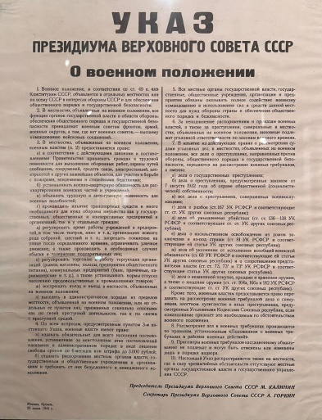Find the document that you see in the picture. Study it and answer the question: what was the name of our country in 1941?*

1. The Union of Soviet Socialist Republics.
2. Union of Soviet Socialist Republics.
3. The Soviet Republic.

**Hall 2**. **Task 2**

*Look at the photo of gas tanks and say what you can see behind them.*

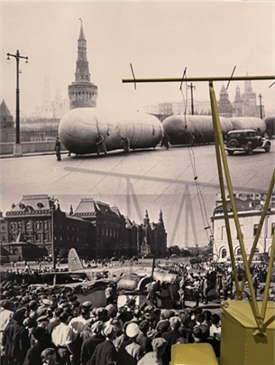

|  |  |  |  |
| --- | --- | --- | --- |
| A | Moscow State University | B | The Moscow Kremlin |
| C | The factory “Red October” | D | The Kremlin of Smolensk |

**Hall 3. Task 3**

*Look at the photo and find this place in Hall 3. ­Choose the words that describe the workplaces of many Muscovites in 1941.*

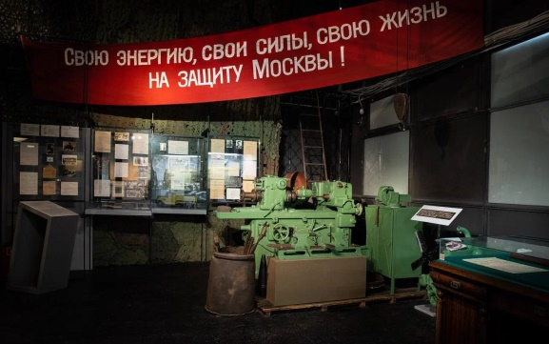

1. Factory, plant, workshop.
2. Bank, office, department.
3. School, college, university.

*What do we call words with similar meanings? ____________________________*

**Task 4**

*Examine the display case next to the kitchen and find a document that Muscovites used to get food in the wartime. Choose all the words which can describe this document.*

* 1. food cards
  2. coupons
  3. ration cards
  4. tickets

*Why can’t we use the word “tickets”?*

*__________________________________________________________________*

*How many grams of bread could a Moscow schoolchild buy at the end of 1941?*

*__________________________________________________________________*

**Task 5**

*Remember how we form ordinal numerals.*

One → first; two → second; three → third

Five → fifth

Twenty → twentieth

Twenty-one → twenty-first

*Write ordinal numbers in English.*

1. Our classroom is on the (3) _______________ floor.
2. My friend has moved to a new flat on the (6) _______________ floor.
3. Their family live in an old house on the (2) _______________ floor.
4. The company’s office is on the (22) _______________ floor.
5. The workshop is on the ground floor and the owner lives on the (1) _______________ one.
6. You can only get to the (23) _______________ floor by lift.

**Task 6**

*Look at the kitchen and the living room, fill in the gaps with the correct words and say which statements are true.*

round radio wash furniture lighter

1. Usually, the whole family gathered to listen to the ________________ in the kitchen.
2. They usually had meals in the kitchen at a ________________ family table.
3. When they needed to ________________, they did it in the living room.
4. The living room was larger and ________________ than the kitchen.
5. Almost all the ________________ in the flat was wooden.

**Task 7**

*Match the objects with their pictures and definitions.*

|  |  |  |
| --- | --- | --- |
| **Picture** | **Object** | **Definition** |
|  |  |  |
|  |  |  |
|  |  |  |
|  |  |  |
|  |  |  |
|  |  |  |

Objects:

1. Table
2. Sewing [ˈsəʊɪŋ] machine
3. Lampshade
4. Sofa
5. Pioneer tie
6. Radio

Definitions:

1. Children aged 10 to 14 usually were pioneers and wore it around their necks.
2. A piece of furniture on which several people can comfortably sit.
3. A cover for a lamp.
4. A device for making clothes at homе.
5. A device for listening to the news, shows or music.
6. A piece of furniture around which a family gathers for meals or games.

**Task 8**

*Varia is an 11-year-old girl who lived in Moscow in 1941. Let’s read a passage from her diary.*

*In the display case in front of the kitchen find a document with the date when ration cards appeared. Fill in the correct date (for example, June, 22, 1941) and complete Varia’s text with the right words.*

limits food cards queue [kjuː] monthly product

Date: ________________

1. ________________ appeared two days ago. Each one has a date, a name of a 2. ________________ and says how many grams of it you can buy. For example, you can buy bread, sugar, meat or fish. My parents have explained to me that there is a 3. ________________ ration. It consists of coupons, one for each day. Each person has their own ration for each day: 400 grams for a schoolchild, 600 grams for a teacher and 800 grams for a factory worker. It’s very sad because there are food   
4. ________________ now.

I’m going outside. We have to stand in a 5. ________________ to get food.

**Task 9**

*Use* ***some (+)*** *or* ***any (- , ?)*** *to fill in the gaps.*

1. Children in Moscow hospitals got _____ letters from soldiers at the front.
2. Libraries lent out _____ books to cheer people up, even in hard times.
3. Did the children have _____ toys to play with during the war?
4. Soldiers gave kids _____ chocolate when they could.
5. There weren’t _____ lights in the streets at night.
6. Women and children planted _____ vegetables in parks.
7. Were there _____ cinemas open in Moscow during the war?
8. Families didn’t have _____ new clothes for many years.
9. Volunteers brought _____ warm clothes for the soldiers.
10. Have you seen _____ old photos of Moscow from that time?

**Task 10**

*Interview your classmate, write down the answers and report them to the group.*

1. Do you live in a house or in a flat?

____________________________________________________________

1. What floor do you live on?

_____________________________________________________________

1. How many rooms do you have in your house or flat?

_____________________________________________________________

1. Who lives together with you?

_____________________________________________________________

1. Name three differences between your kitchen and living room and the ones from 1941.

__________________________________________________________________________________________________________________________________________________________________________________________________________________________________________________________________________________________________________________________________________________________________________________________________________________________________________________________________________________________________________________________________________________________________________________________________________________________________

**Task 11**

*Do the crossword puzzle.*

1. The Union of Soviet Socialist Republics.
2. A piece of furniture in the living room where several people can comfortably sit.
3. One of the rooms of the flat where people usually sleep.
4. A very popular product many people eat every day.
5. The capital of Russia.
6. A military conflict between counties.

|  |  |  |  |  |  |  |  |  |
| --- | --- | --- | --- | --- | --- | --- | --- | --- |
|  |  | 1 |  |  |  |  |  |  |
| 5 |  |  |  |  | 6 |  |  | 3 |
|  |  | 2 |  |  |  |  |  |  |
|  |  |  |  | 4 |  |  |  |  |
|  |  |  |  |  |  |  |  |  |
|  |  |  |  |  |  |  |  |  |
|  |  |  |  |  |  |  |  |  |
|  |  |  |  |  |  |  |  |  |